Quantitative Risk Assessment Using the Indicators & Warning (I&W) Technique
Pfizer Inc. / Seagen Acquisition | Group 10 | Module 3

Appendix A Quantitative Model (Monte Carlo Notebook)
The full model is available as the runnable Jupyter notebook Group10_M3_Quant_IW_MonteCarlo.ipynb. It defines the I&W input parameters directly in the notebook, runs 100,000 Monte Carlo iterations per risk, and generates the four visualizations shown below. The results table is also saved on Google Drive.

A.1 Simulation results
Risk | Type | Mean Prob. | Impact P50 ($B) | Exp. Loss/Value ($B) | Scenario VaR P90 ($B)
R-MSE ADC market-share erosion | Threat | 53.3% | 4.86 | −2.66 | 6.67
R-006 Critical ADC talent poaching | Threat | 55.0% | 0.65 | −0.37 | 0.87
R-010 First-mover ADC combinations | Opportunity | 50.0% | 1.64 | +0.83 | +1.95

A.2 Core implementation
import numpy as np, pandas as pd
rng = np.random.default_rng(42); N = 100_000

# I&W parameters (triangular probability & impact $B)
inp = pd.DataFrame([
{'risk_id':'R-MSE','p_min':.30,'p_mode':.55,'p_max':.75,'imp_min':1.00,'imp_mode':4.42,'imp_max':9.57},
{'risk_id':'R-006','p_min':.35,'p_mode':.55,'p_max':.75,'imp_min':0.20,'imp_mode':0.60,'imp_max':1.20},
{'risk_id':'R-010','p_min':.30,'p_mode':.50,'p_max':.70,'imp_min':1.00,'imp_mode':1.50,'imp_max':2.50}])

def tri(a,m,b): return rng.triangular(a,m,b,N)
for _, r in inp.iterrows():
p = tri(r.p_min, r.p_mode, r.p_max) # probability
imp = tri(r.imp_min, r.imp_mode, r.imp_max) # impact ($B)
el = p * imp # expected loss/value
scen = np.where(rng.random(N) < p, imp, 0.0) # scenario (VaR) view
# record mean(p), P50/P90(imp), mean(el), P90(scen) ...

A.3 Visualizations
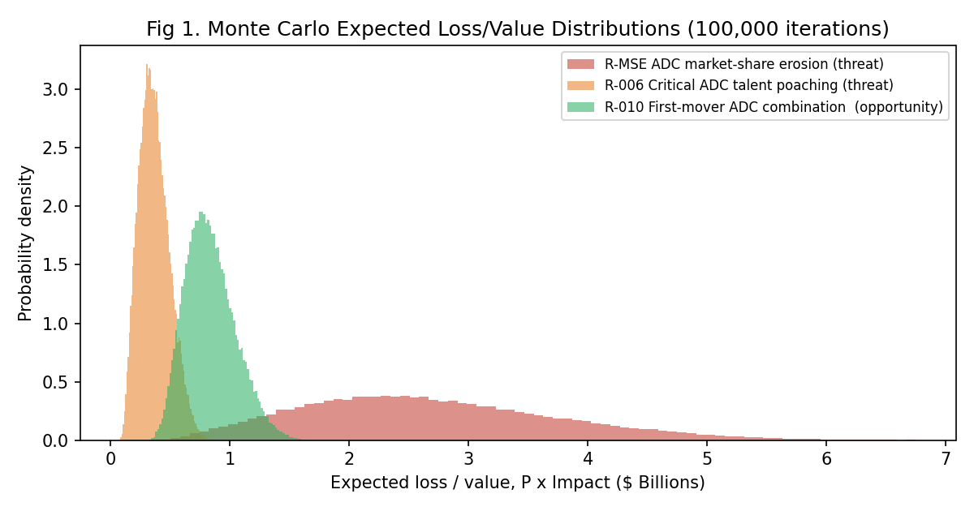
Figure A-1. Monte Carlo expected loss/value distributions (100,000 iterations).
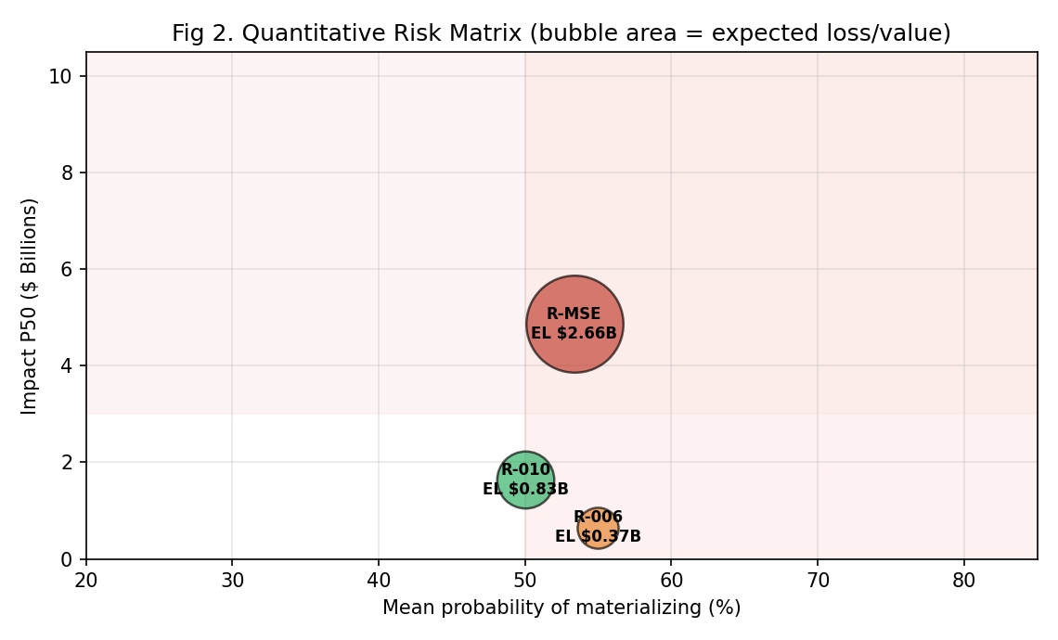
Figure A-2. Quantitative risk matrix — probability vs. impact; bubble area = expected loss/value.
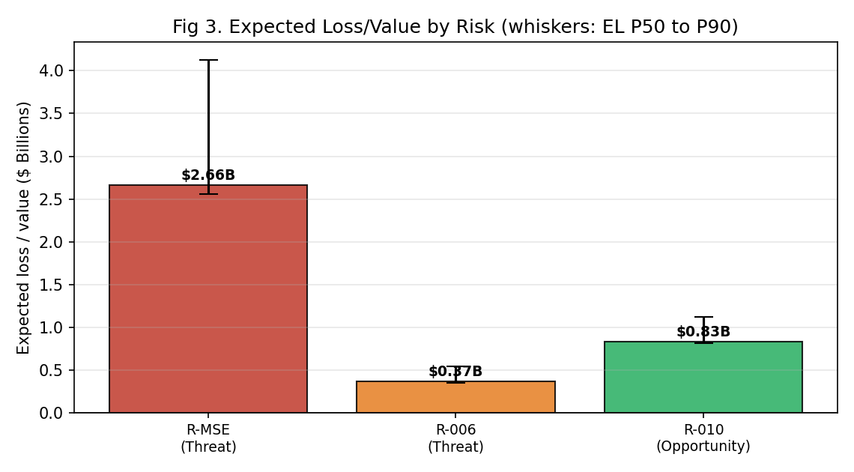
Figure A-3. Expected loss/value by risk; whiskers span EL P50 to P90.
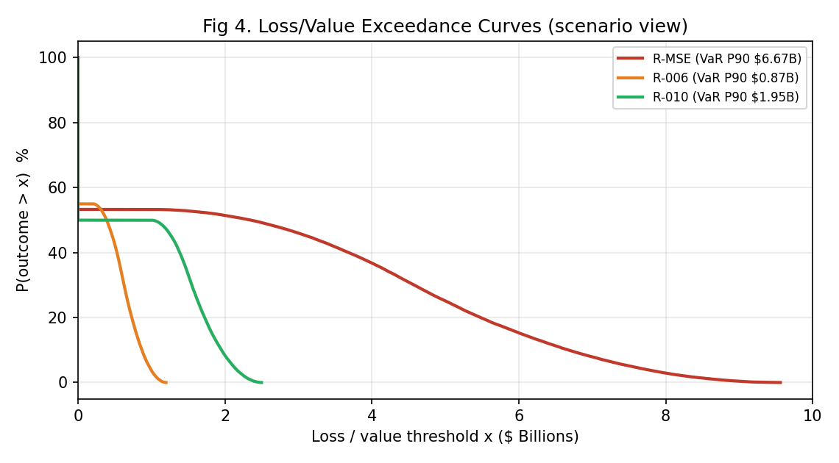
Figure A-4. Loss/value exceedance curves; the P90 point is the scenario value-at-risk.
Appendix B Data Source (I&W Input Parameters)

The inputs below are packaged as the data source file Group10_M3_IW_DataSource.csv and mirrored in the notebook. Each probability range is based on the risk’s I&W indicator readings at the time of assessment; each impact range is tied directly to the Group 10 DCF model and the figures in the Risk Register.
Risk ID | Risk | Type | Probability (min/mode/max) | Impact $B (min/mode/max)
R-MSE | ADC market-share erosion | Threat | 0.30 / 0.55 / 0.75 | 1.00 / 4.42 / 9.57
R-006 | Critical ADC talent poaching | Threat | 0.35 / 0.55 / 0.75 | 0.20 / 0.60 / 1.20
R-010 | First-mover ADC combination advantage | Opportunity | 0.30 / 0.50 / 0.70 | 1.00 / 1.50 / 2.50

Indicators, warning triggers, and provenance
R-MSE ADC market-share erosion. What we watch: competitor ADC approvals and Phase 3 starts; Seagen’s ADC share trend; Enhertu vs. PADCEV growth trajectory. Escalation trigger: Seagen ADC share falling more than 5% per year, or three or more competitor ADC approvals in a year. Where the data comes from: ClinicalTrials.gov, Drugs@FDA, SEC EDGAR, Group 10 DCF model.
R-006 Critical ADC talent poaching. What we watch: annualised attrition among critical scientists; active recruitment by rival firms (AbbVie, Merck); retention-offer acceptance rates. Escalation trigger: annualised attrition above 8% hits red; 5 8% sits at amber. Where the data comes from: Array BioPharma 2019 post-acquisition precedent, Munos (2009), Risk Register R-006.
R-010 First-mover ADC combination advantage. What we watch: new ADC combination programs initiated per quarter; academic partnership signings; competitor partnership announcements. Capture trigger: four or more new combination programs per quarter within the 24–36 month window signals the opportunity is being actively seized. Where the data comes from: Risk Register R-010, MD Anderson / Sloan Kettering / Dana-Farber pipeline data.
Supporting data is also shared via Google Drive: riskregister.csv (the qualitative register) and the published Monte Carlo results.

